Michael Thompson
09/13/2026
Threat Model LAB-002
Before I start (SetUp)
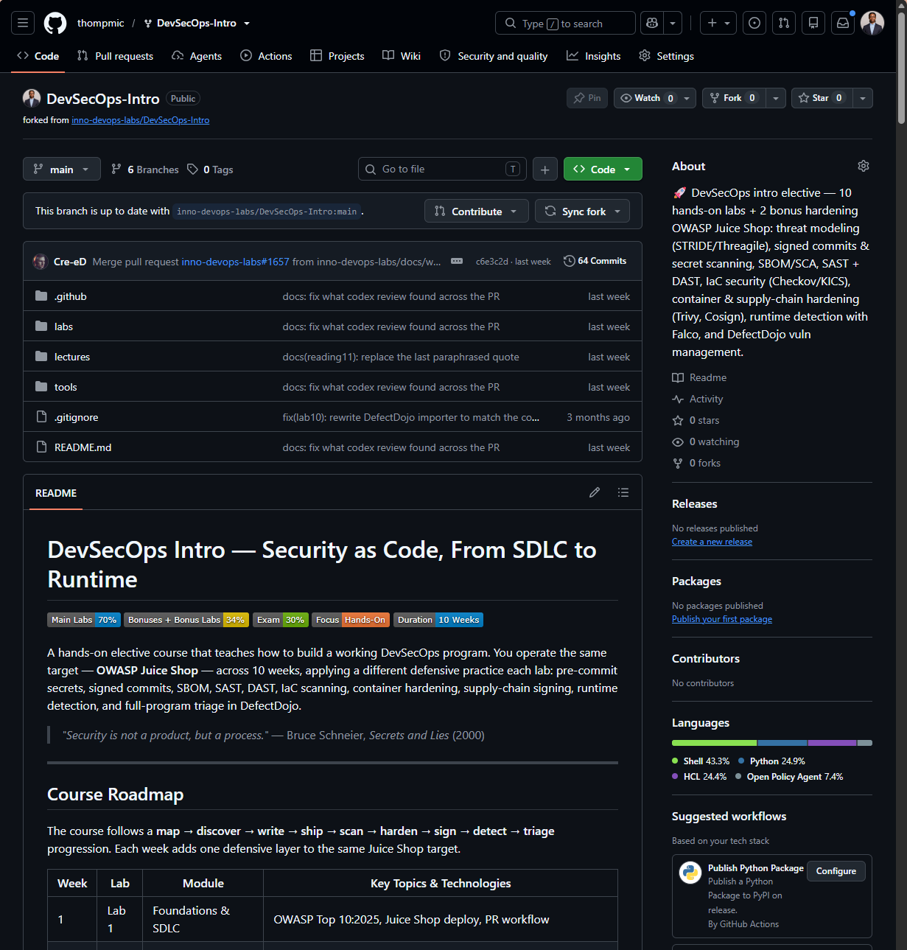
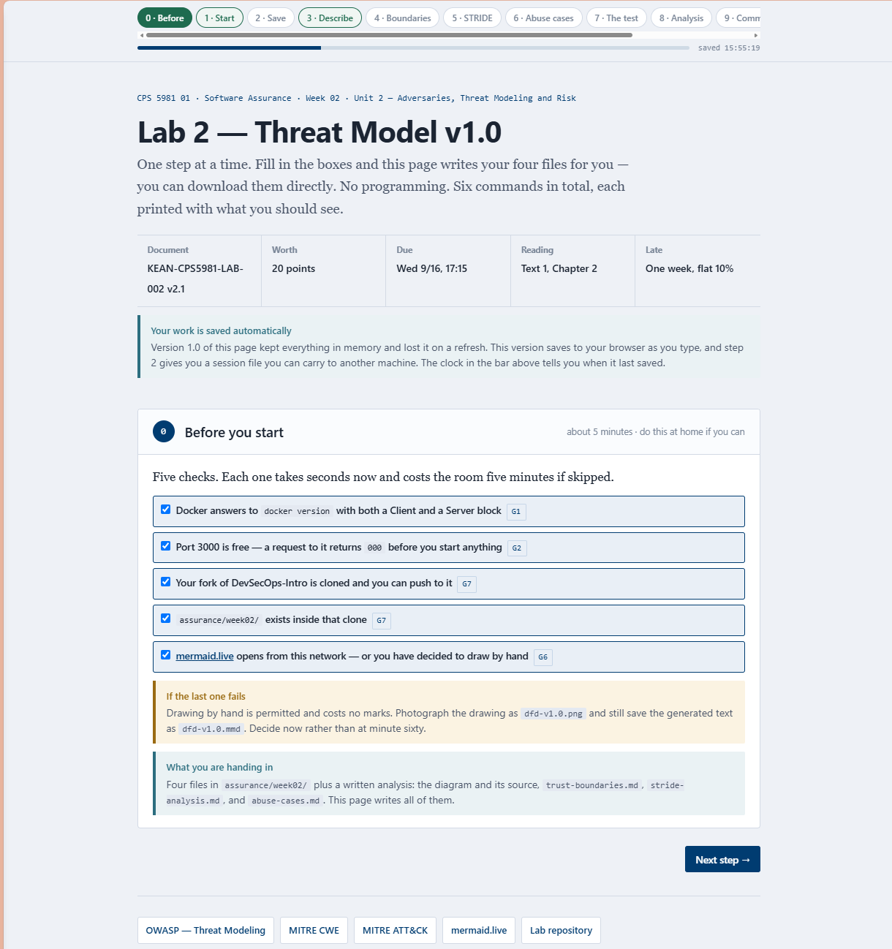
Start the target and look at it
Run docker
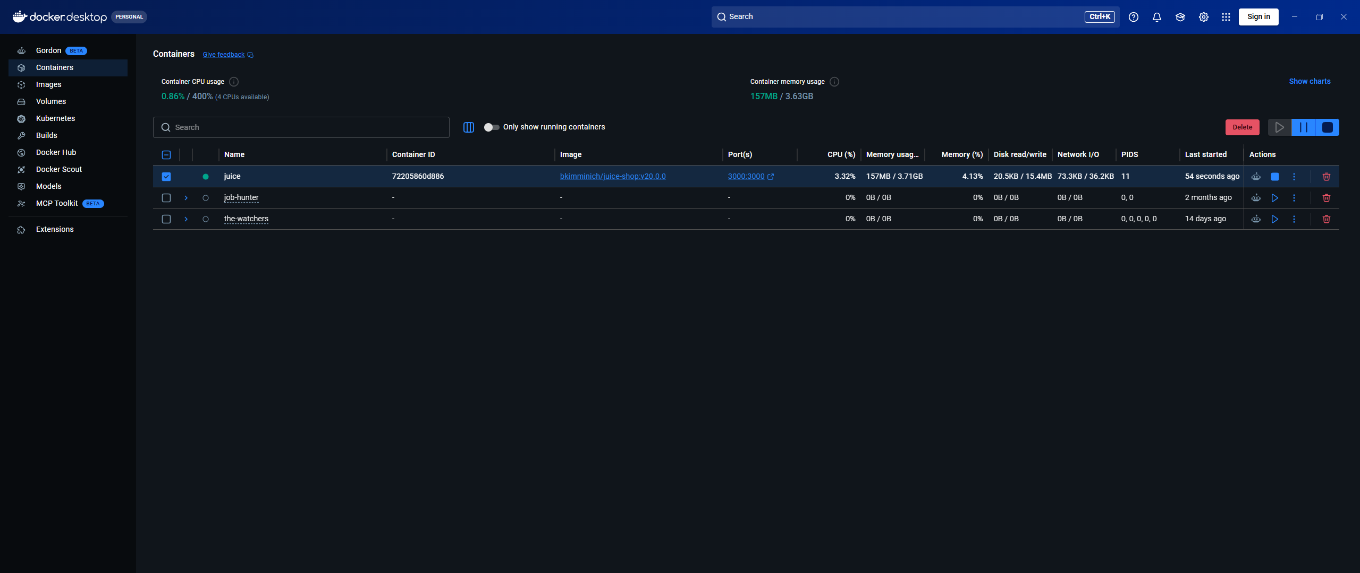
Port3000
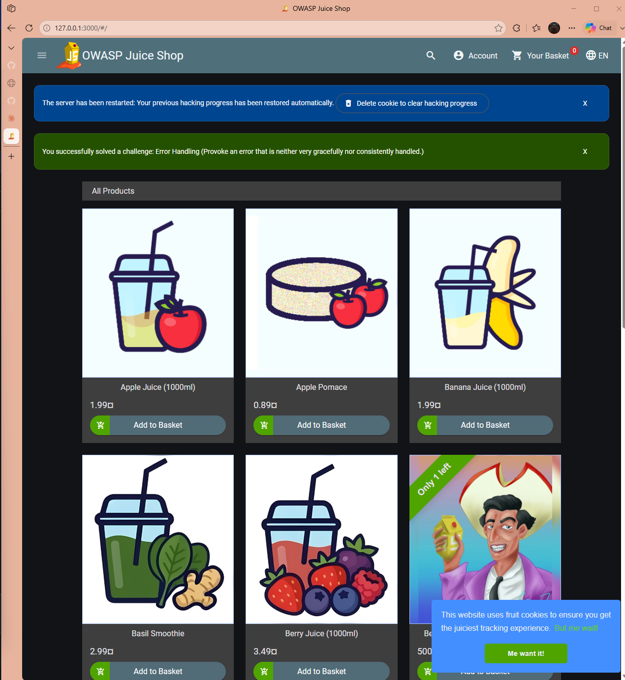
Signed in using my Kean account but this doesn’t create a account. I clicked around.
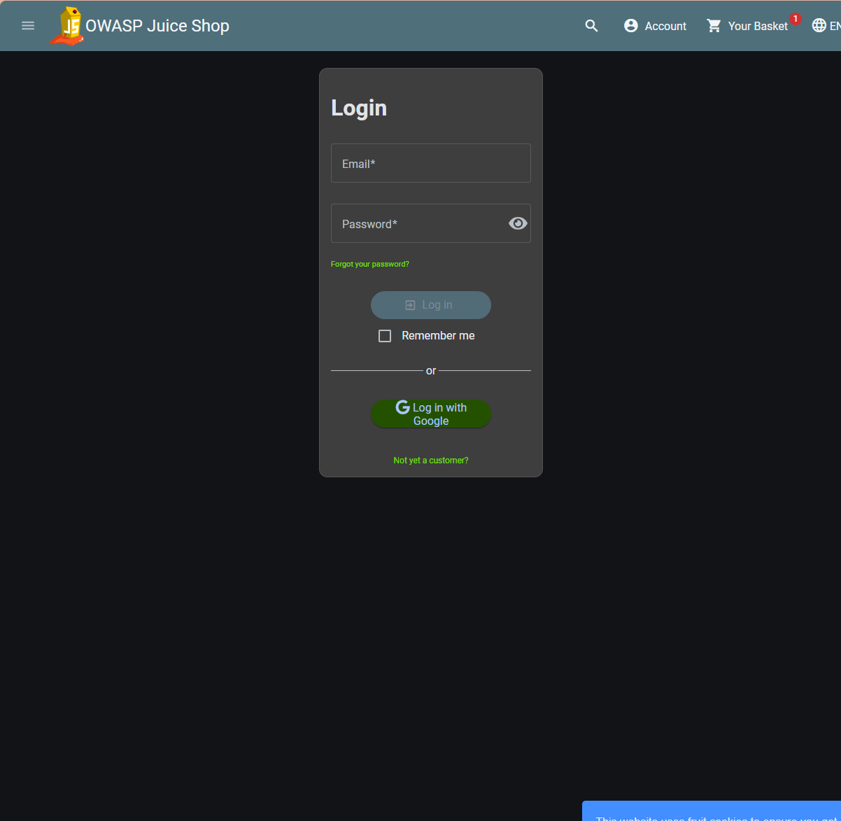
Picked an item
Added to cart
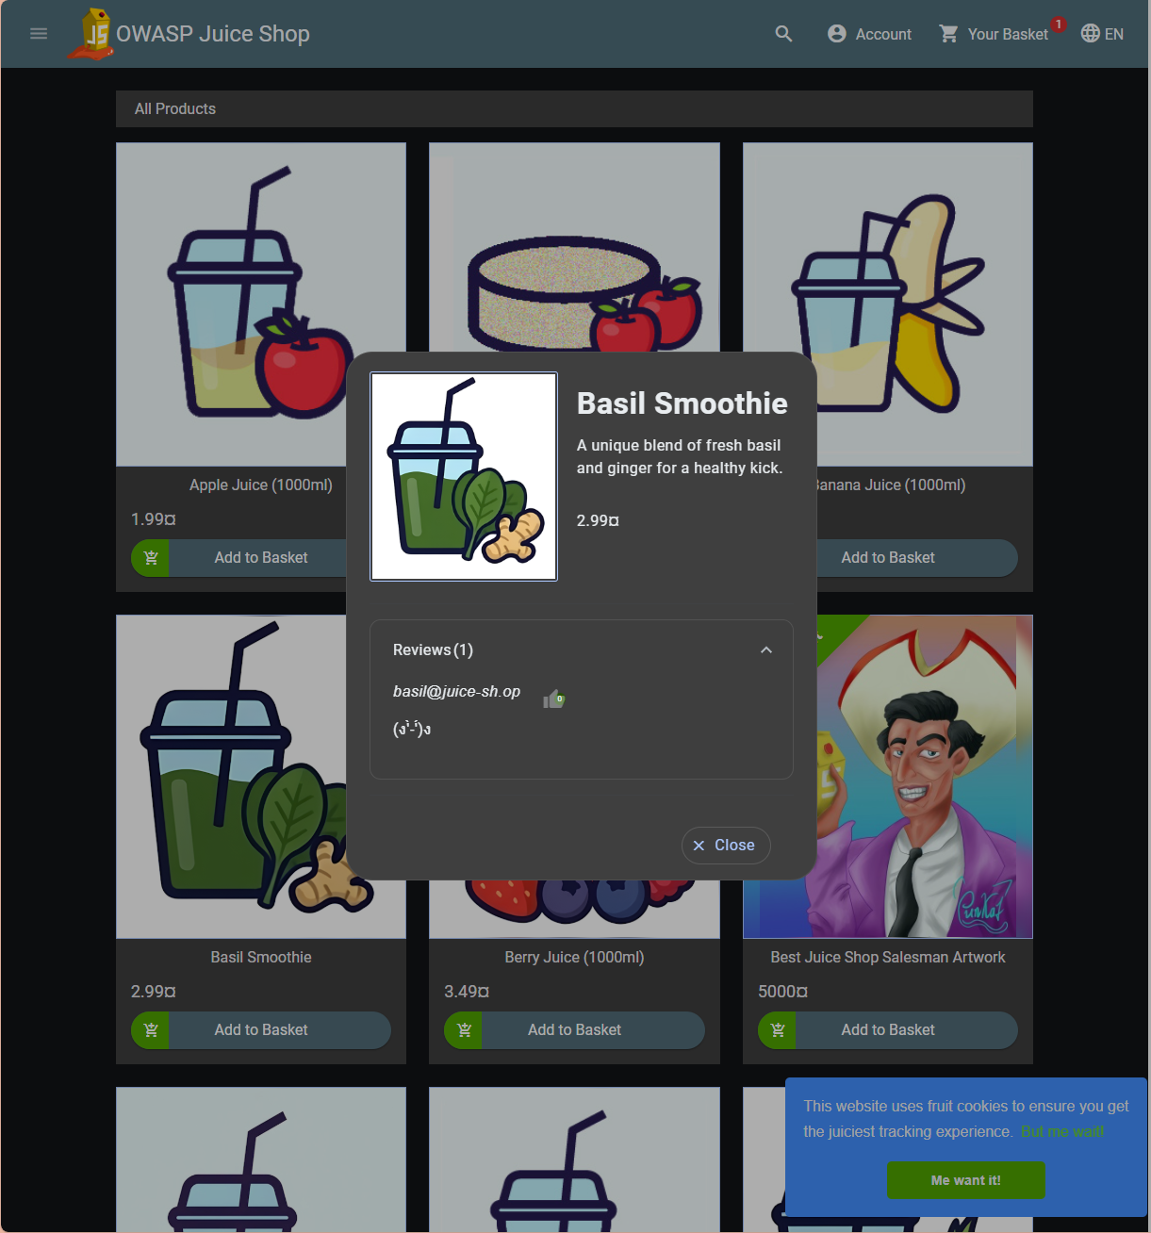
I had to register an account
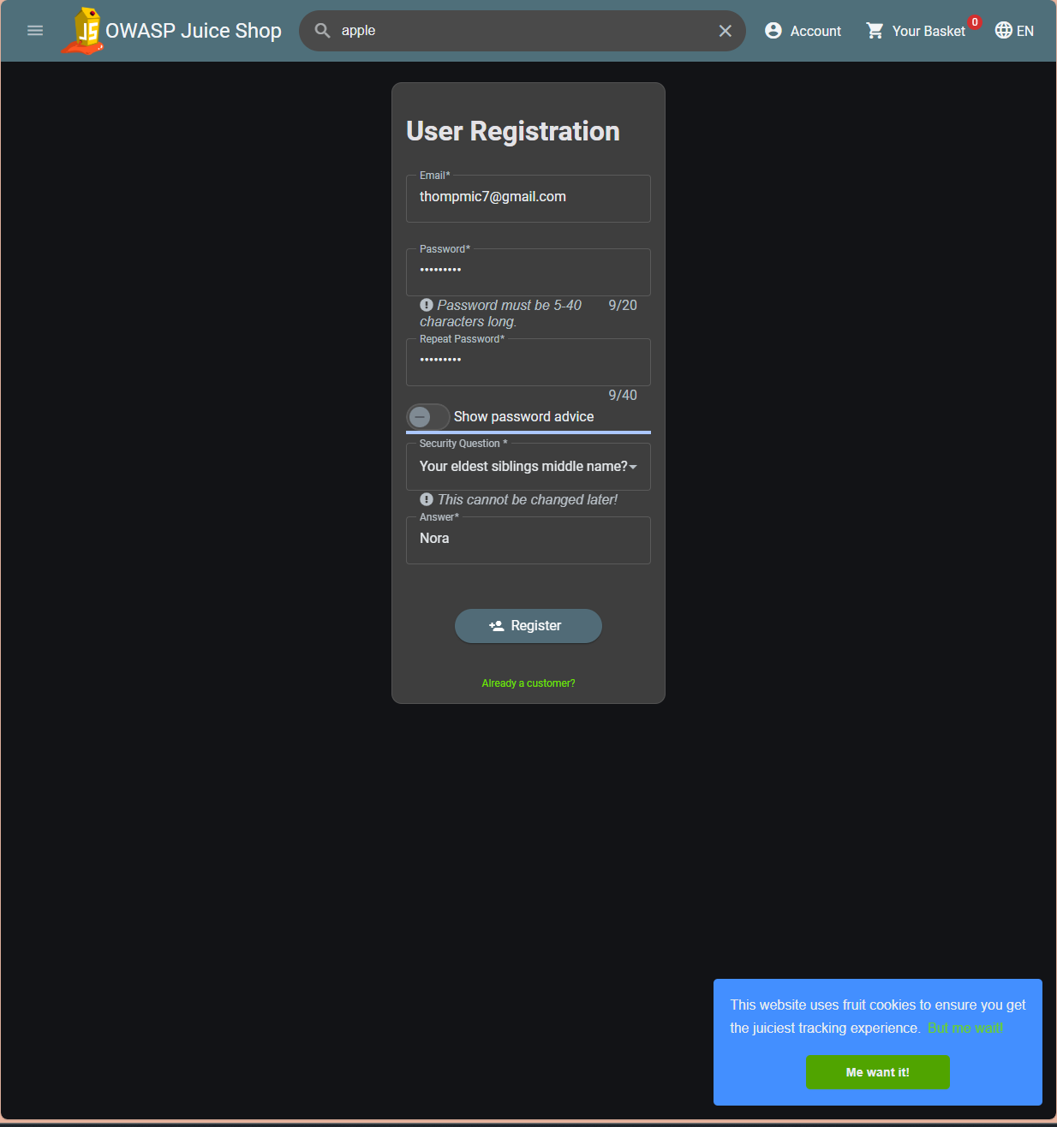
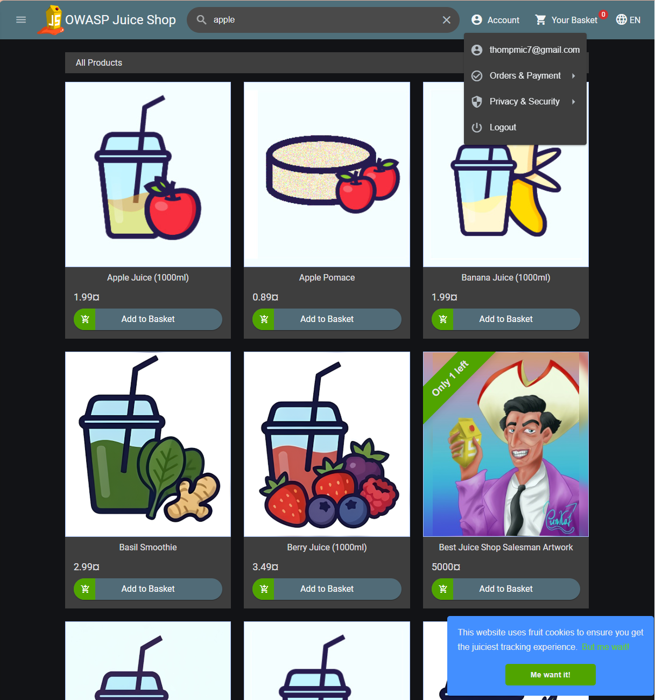
More information when clicking around
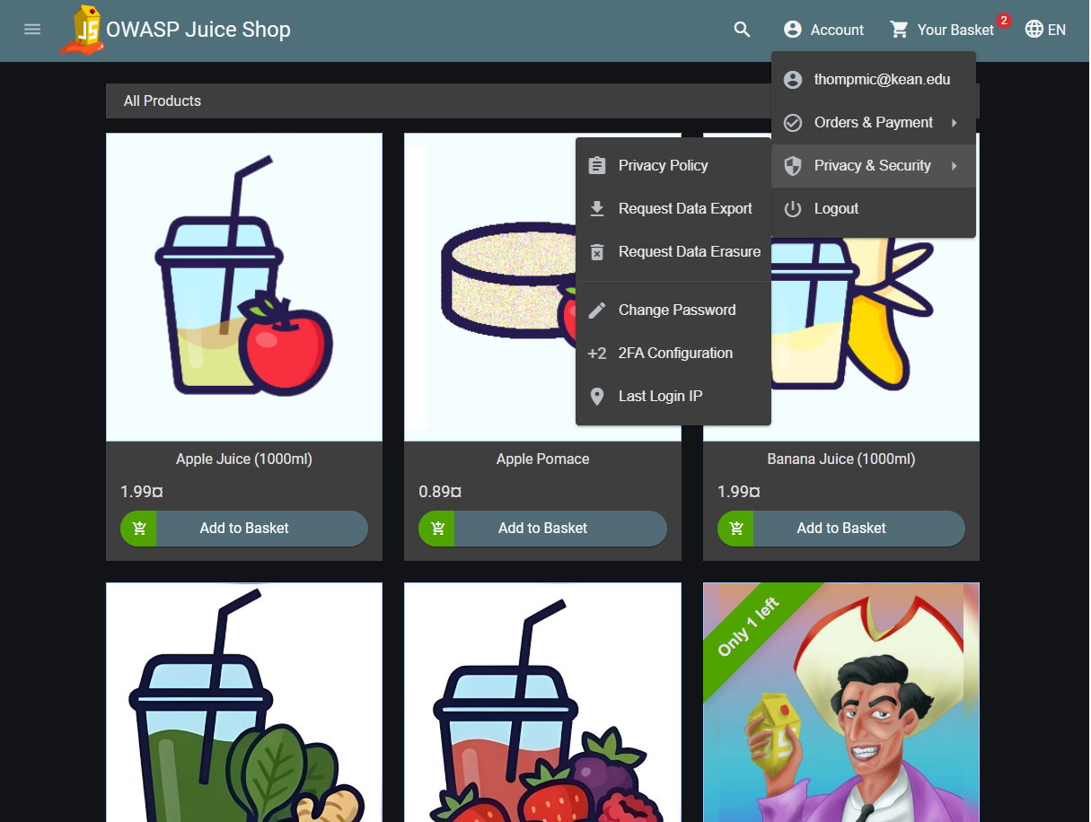
I then searched for an item
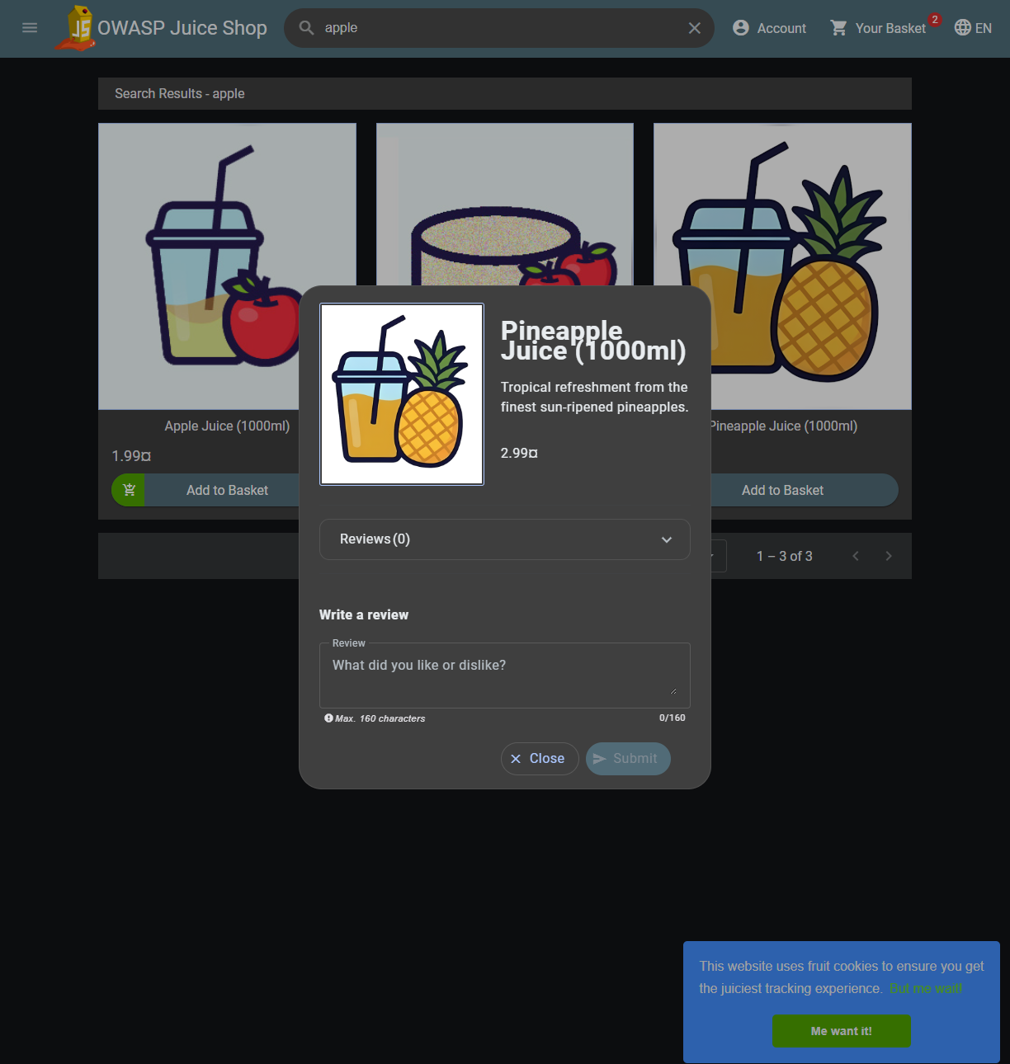
Pineapple Juice. apple is a substring of Pineapple. The search does substring matching against product text server-side. My search term is being interpolated into a lookup. I observed that, but the bigger find is the bottom half of that dialog. I captured a "Write a review" form — a textarea, Max. 160 characters, a Submit button, on a product page while signed in as thompmic@kean.edu. The search term reaches a server-side lookup that does substring matching
Uploading image
{"error":"File is not passed"}
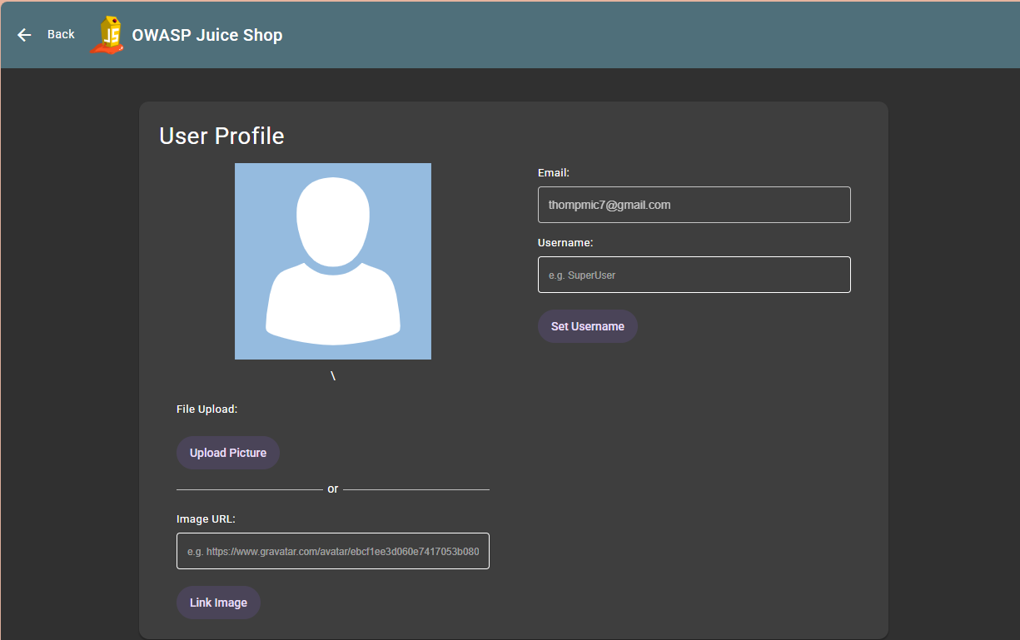
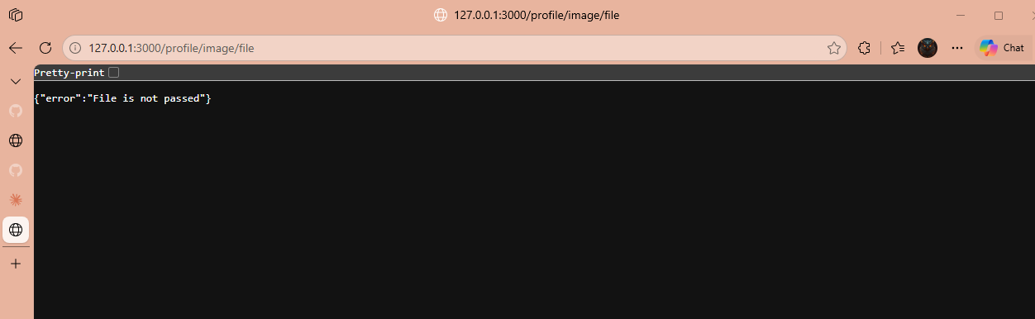
Note:
Also notice: /profile looks nothing like the rest of the app — no Account menu, no basket, a plain "Back" link, a full page load. The shop is a single-page app; this page isn't

The diagram
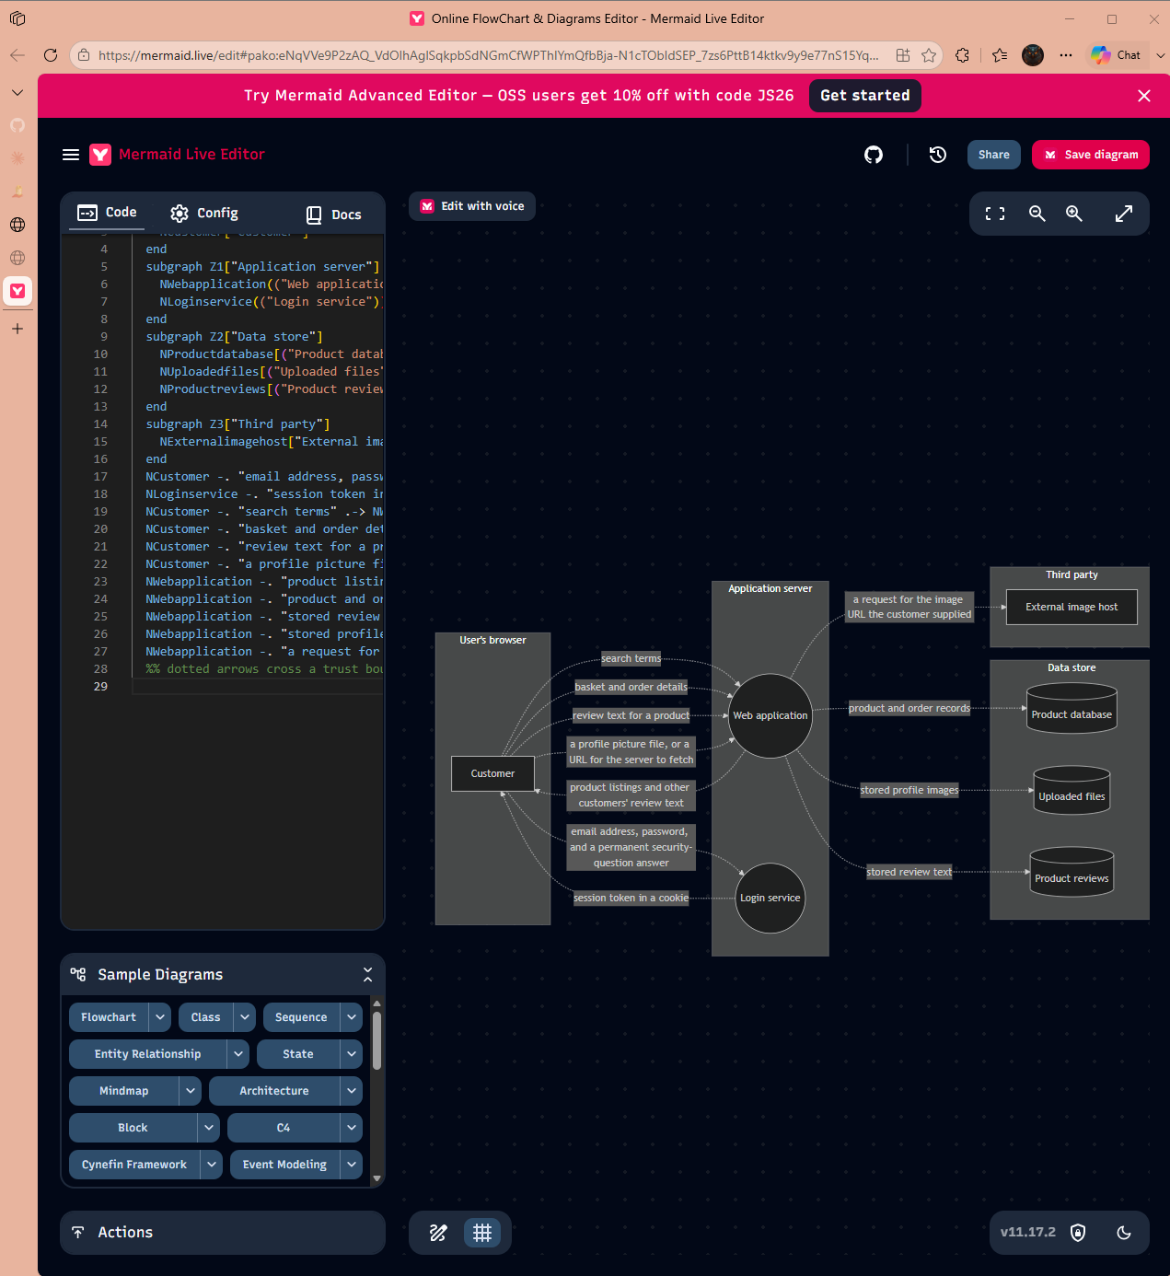
Completed the Boundaries

STEP 5 – STRIDE

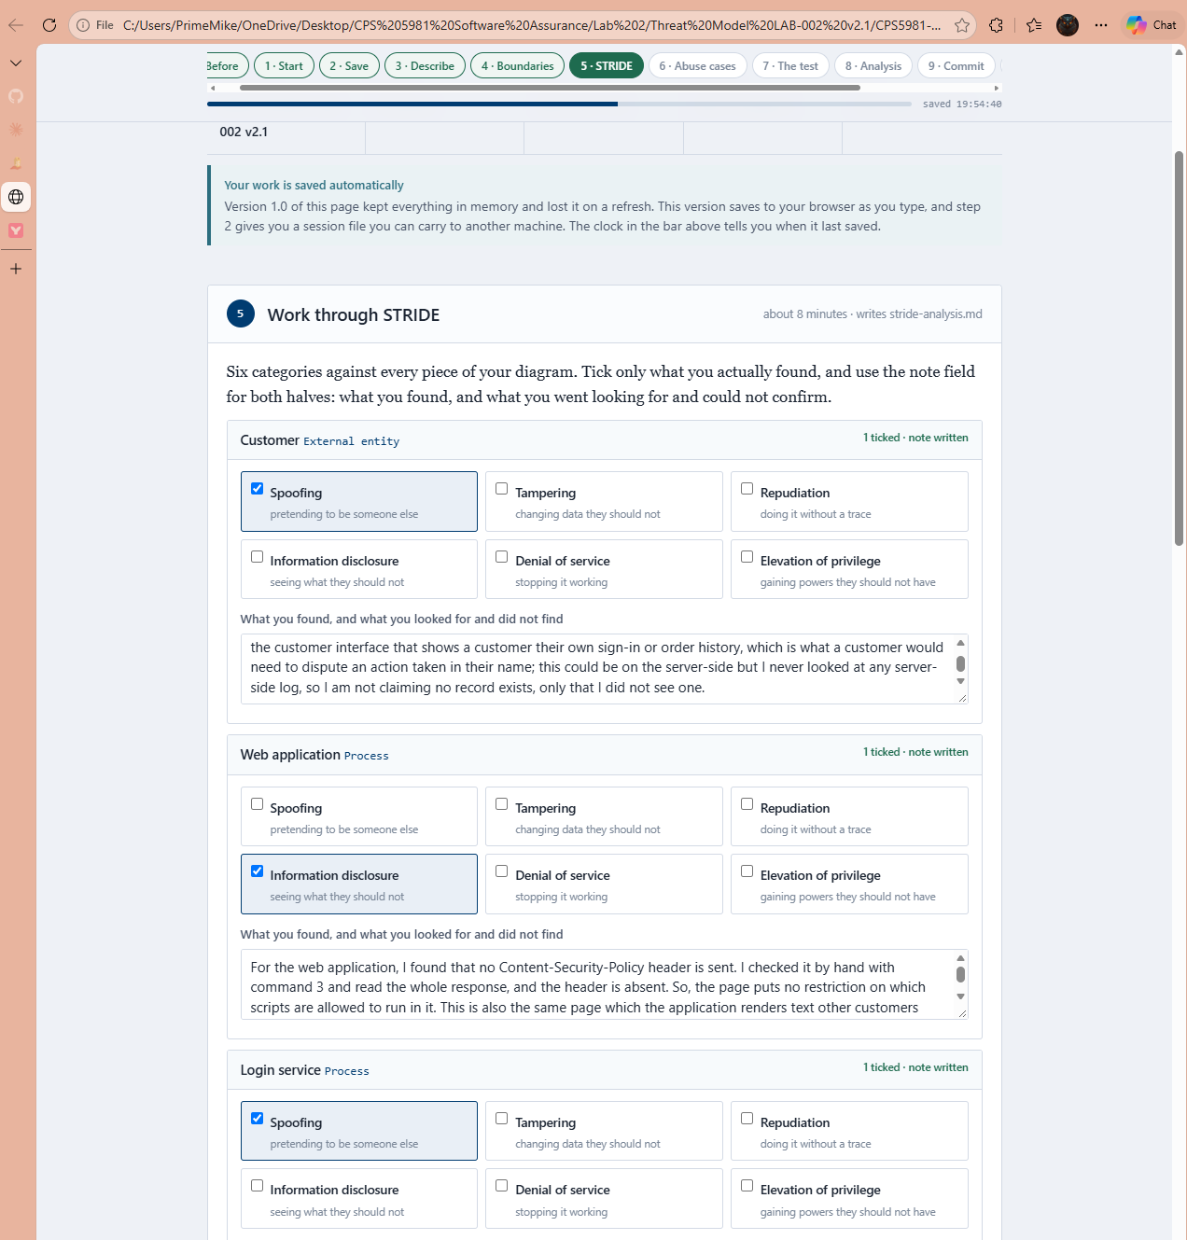
The Abuse Cases

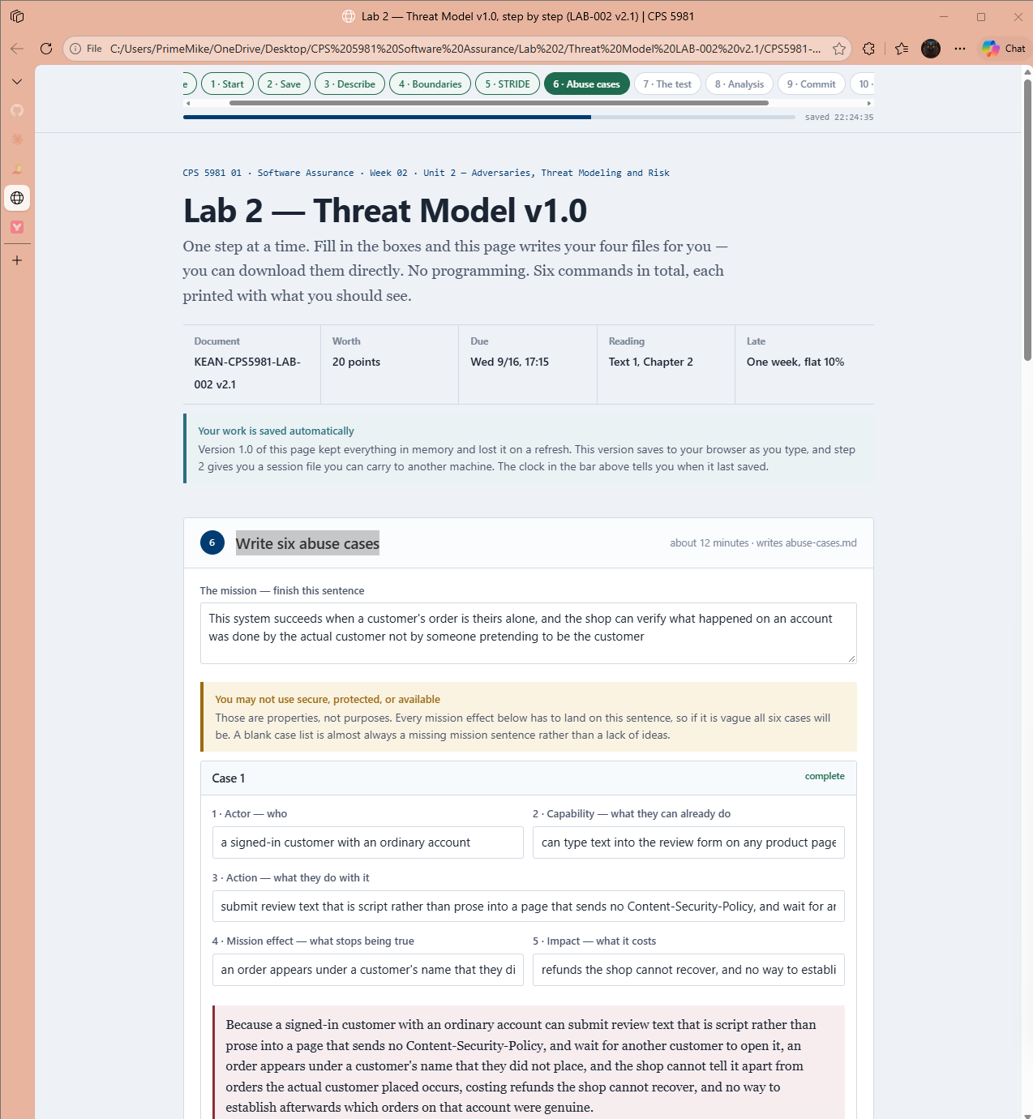
The Consequence Test
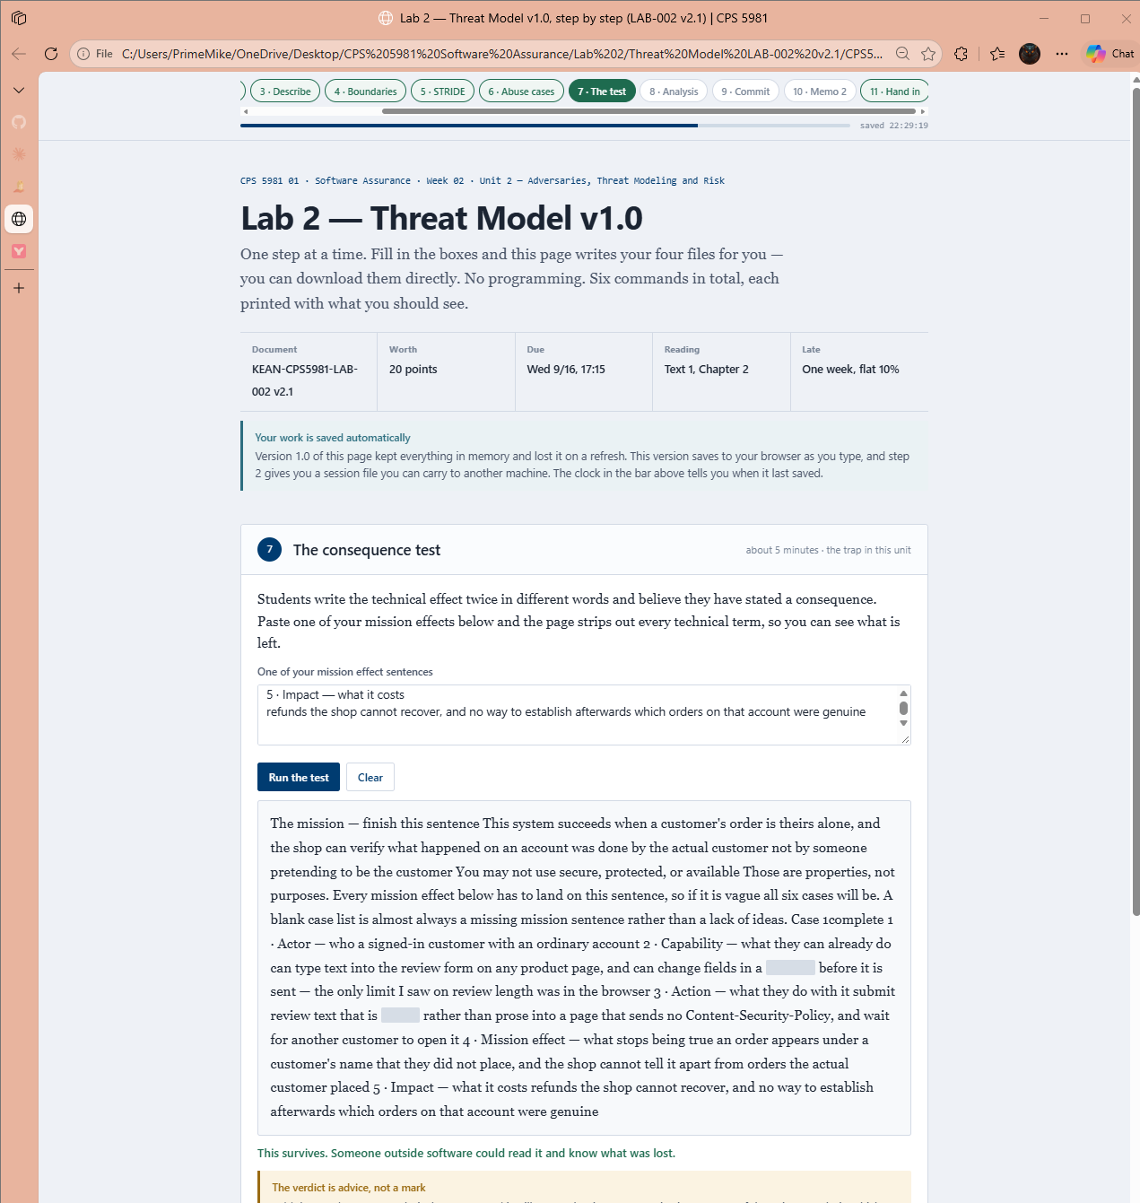

Analysis
